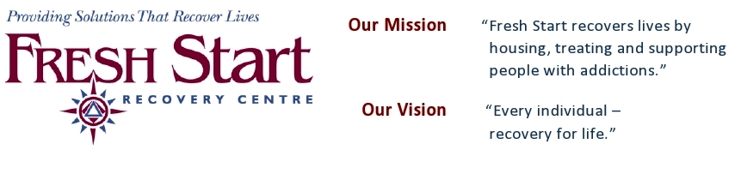

How to Transfer Your Marketable Securities to
Fresh Start Recovery Centre

1) Electronic Transfer
- Please contact Fresh Start Recovery Centre one day prior to your planned transfer of shares to discuss the shares being considered. This will allow us to confirm their eligibility for receipting purposes and ensure that the necessary follow-up occurs.

- Please send a list of the assets to Mr. Rod Garossino, Director of Fund Development, Telephone (587) 777-8332. His email contact is rodg@freshsrtartrecovery.ca. Please copy Pat Cole at pat@freshstartrecovery.ca or call (403) 387-6266.

- Your broker can arrange for the electronic transfer of shares to RBC Dominion Securities Account No. 701-81232-11. The attached information sheet “Detailed Instructions for Electronic Transfer of Securities” provides all required information or you may contact Joey Weber at (403) 299-7150 joey.weber@rbc.com or Matt Weber (403) 299-7080 matt.weber@rbc.com Canadian Book-Based Transactions.

- Please inform us once the transfer has been completed.

2) Physical Delivery of Certified Securities
- Arrangements for pick-up and delivery to the Society’s custodian are available, or you can send the shares to
Fresh Start Recovery Centre
411 41st Avenue NE
Calgary, Alberta
T2E 2N4

- Please notify Mr. Rod Garossino of the securities’ pending delivery.
His phone number is (587) 777-8332.
Your Donation Receipt
- The value of the donation receipt is based on the closing price of the security on the day the securities are received by the Society’s custodian.

Letter of Direction
- A Letter of Direction is attached for your convenience. This can be used both to advise Fresh Start Recovery Centre of your intentions and to authorize your Investment Advisor to proceed.

Detailed Instructions for Electronic Transfer of Securities
- A list of detailed instructions for electronic transfers of securities is also attached.
Fresh Start Recovery Centre Charitable Registration number is
13672 0737 RR0001

Letter of Direction - For Transfer of Marketable Securities

From: __________________________________________________________________ (Your Name)

________________________________________________________________________
(Your Address)

To: Fresh Start Recovery Centre

Investment Advisor:

(Your Advisor’s Name)

Address/Fax No:

(Your Advisor’s address & fax number)

Re: Transfer of Marketable Securities

This letter is to authorize the transfer of the following marketable securities currently owned by me/us, from our accounts to account 701-81232-11. Please process this transaction immediately. If applicable, please forward the securities and paperwork to Joey Weber, RBC Dominion Securities Inc, 1400, 333-7th Avenue SW Calgary, AB T2P 2Z1.

of currently in account
# of units description of security acct no. if known

of currently in account
# of units description of security acct no. if known

of currently in account
# of units description of security acct no. if known

Yours sincerely,

Your Name or Name of Corporation Signing Officers

Detailed Instructions for Electronic Transfers of Securities
A donor would provide a LETTER OF DIRECTION to their brokerage firm indicating that they wished to donate X amount of shares of Y Company to Fresh Start Recovery Centre.
For example, the donor would direct their brokerage firm to transfer on their behalf from their account 123-45678-90 300 shares of Power Corporation of Canada (an example) to the Fresh Start Recovery Centre investment account, 701-81232-11, held at RBC Dominion Securities Inc., Dealer Code 9190, Representative Code RKV, FINS # T002, CUID DOMA, DTC 5002, EUROCLEAR # 90065. The donor should also include the following "Receiving Institution" information:
Fresh Start Addictions Centre Account 701-81232-11
C/O RBC Dominion Securities Inc.
1400, 333-7th Avenue SW
Calgary, AB T2P 2Z1
Attn: Joey Weber Ph: (403) 299-7150

